

G2 EE

Inventory transfer (non AS)

QAD EE Training Document

Inventory Transfer (non AS)

Table of Contents
Objective 3
*Transfer - Single Item 3.4.1 3
Transfer - Multi Item 3.4.2 4

Objective
The purpose of this document is to explain inventory transfers in QAD not involving the AS warehouse management system.

*Transfer - Single Item 3.4.1
This program can be used when one item is to be transferred between locations.
The overall quantities in the system are not changed.
Enter the data for the part to be transferred, the quantity and the from and to locations:
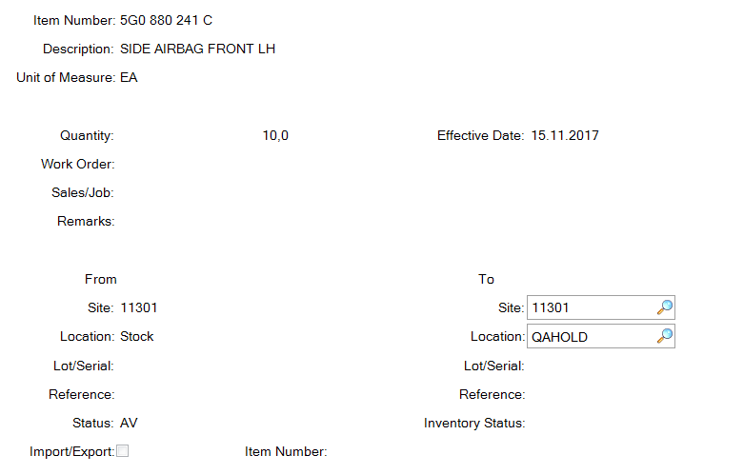

If the status of the two locations is different then you will be asked if you want to take the status of the ‘to’ location. Click Yes.

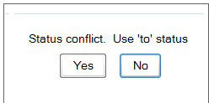
You will be asked if all information is correct. Click Yes.
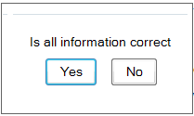
To check the transferred quantities etc. you can use various reports, for example 3.21.2
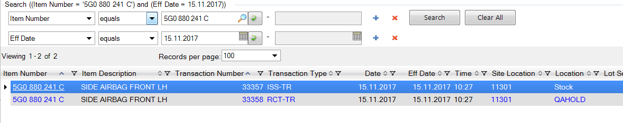
Scroll further right for further information, such as the user who performed the transaction.

Transfer - Multi Item 3.4.2
This program can be used to transfer multiple items between locations. Typically it is used to empty a location onto another location. If not all parts on a particular location are to be transferred it is better to use a CIM load. This avoids parts being transferred by mistake.
The overall quantities in the system are not changed.
Enter the data for the transfer. If the status of the two locations is different then you must select the check box or no transfer will be made.
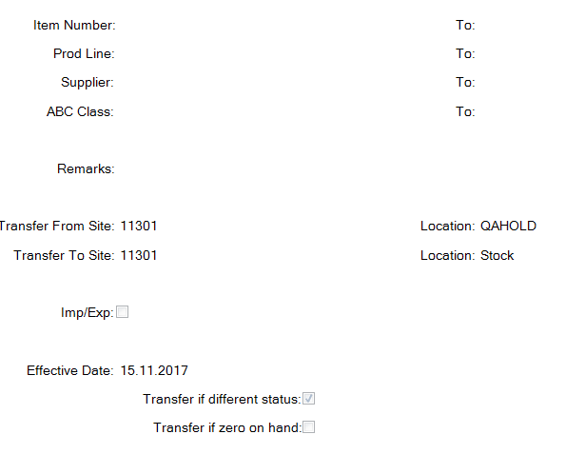
Once the data is complete click next and a report will automatically be generated showing the parts transferred.

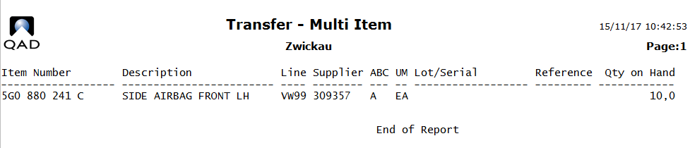

You can use the Inventory Detail by Item Browse 75.7.2.12 to check the inventory on the location before and after the transfer.
Before:
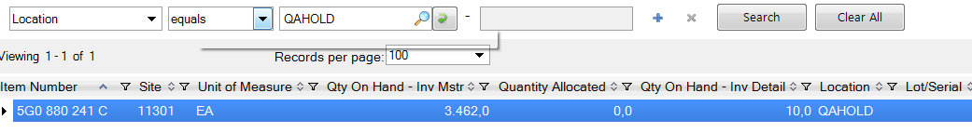
After:
